- Log in to your CSG Forte Dex platform.
- On the left-hand side, Select Transactions.
- Under the Details tab, adjust the time frame for the transactions you would like to search.
  - i.e., 01/01/2023 ---> 06/06/2023
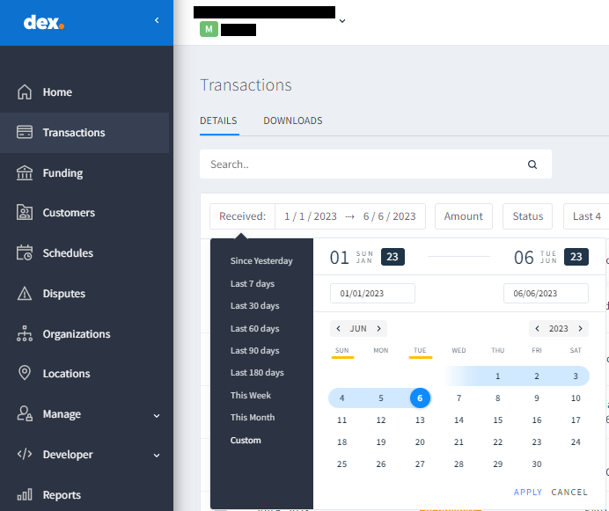
  - Click Apply.
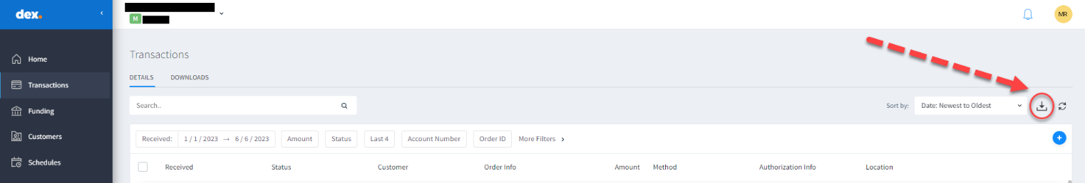
- At the top right-hand side of the screen, Select the Download button ().
- A new display will populate with additional options to include in your transaction report before initiating the full download.
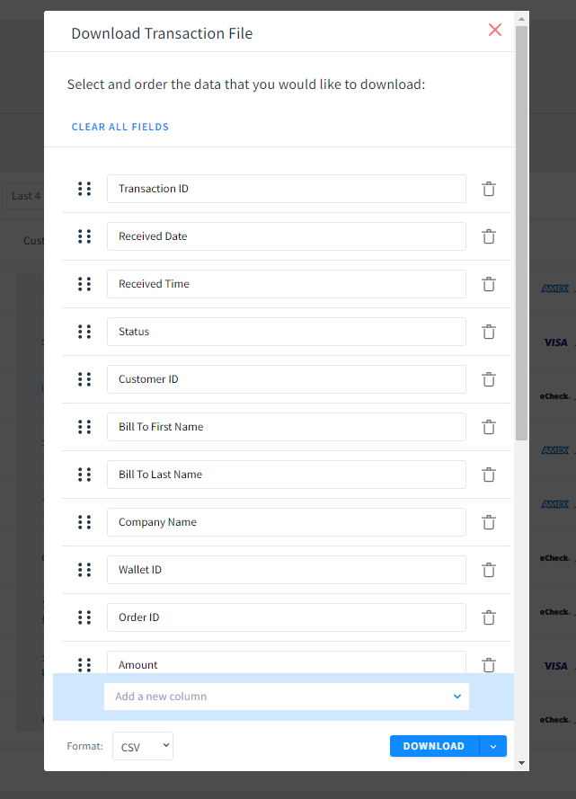
- Click Add a new column.
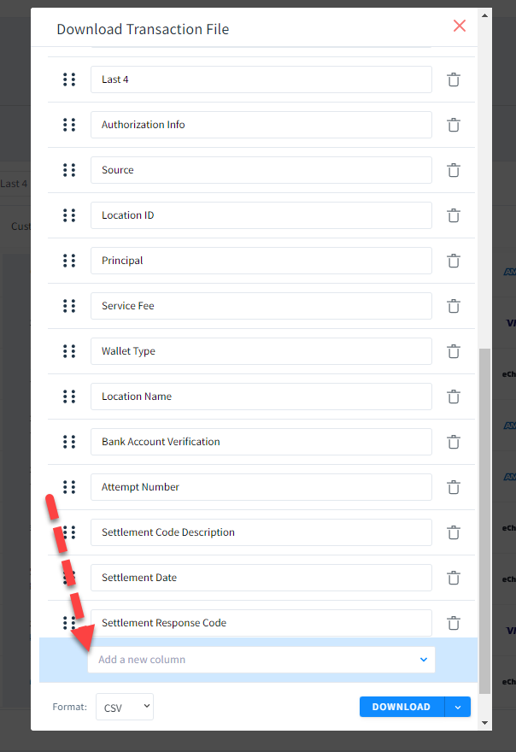
- Select Attempt Number, Settlement Code Description, Settlement Date and Settlement Response Code.
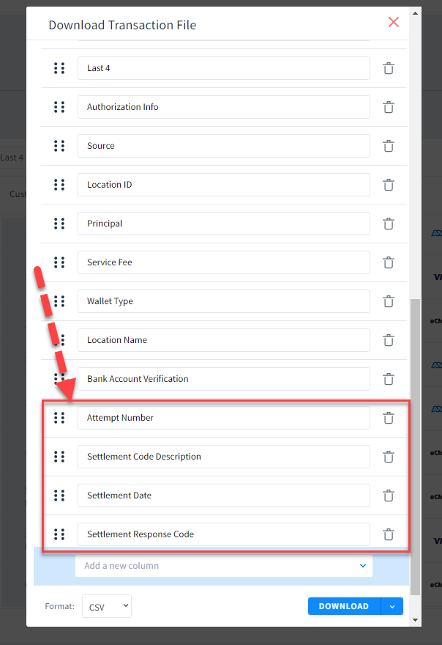
- Move the four additional codes up the list using the 6 dots to the left of the description item to your preference for reconciling the data.
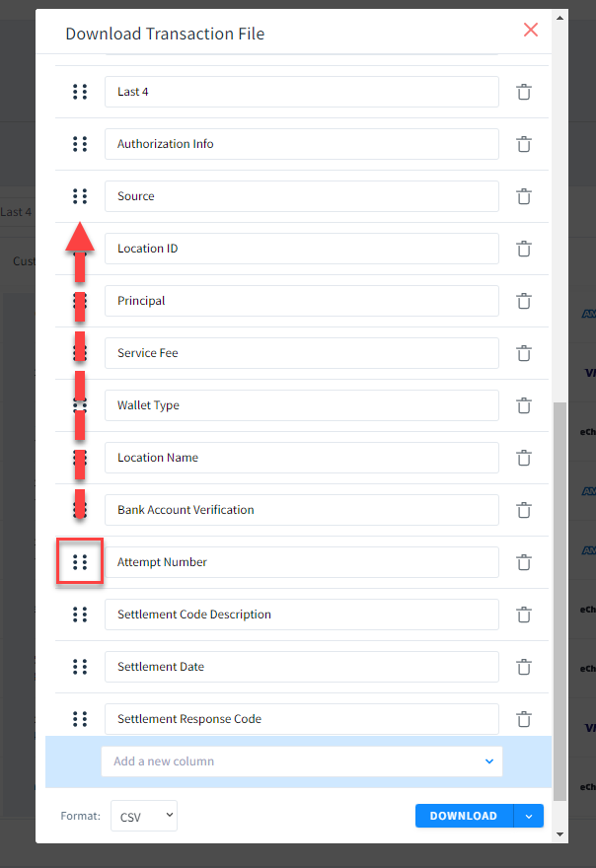
- Here is an example of a adjustment of the description items to better reconcile the information.
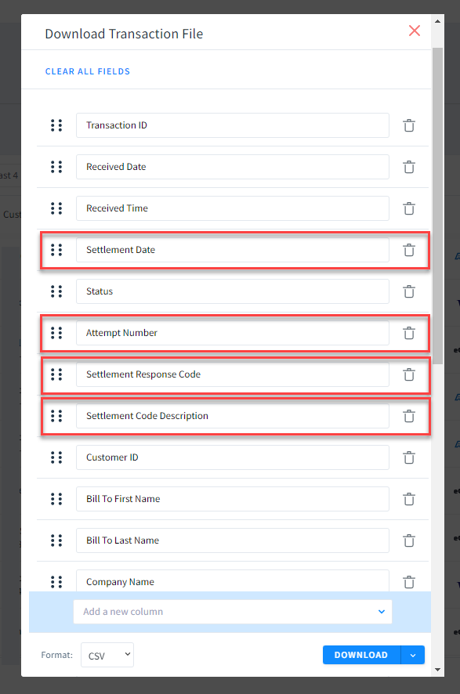
- Click Download.
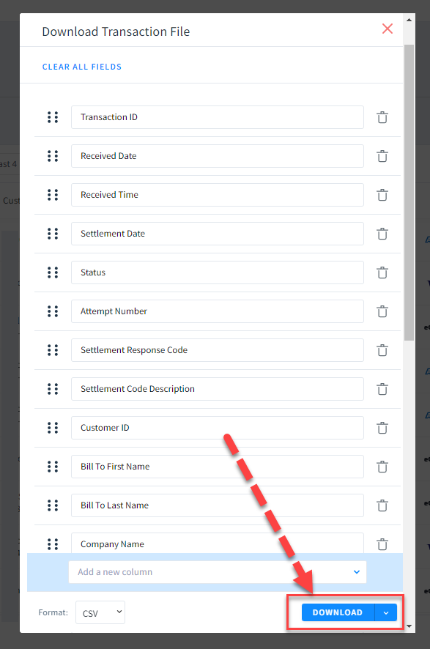
- A notification will present itself at the top right of the site indicating that your document is ready to be downloaded.
  - The document will load at the bottom left of your screen in a csv. Excel document.
  - You can also access the documents you have requested to download in the Downloads tab located by the Details tab.
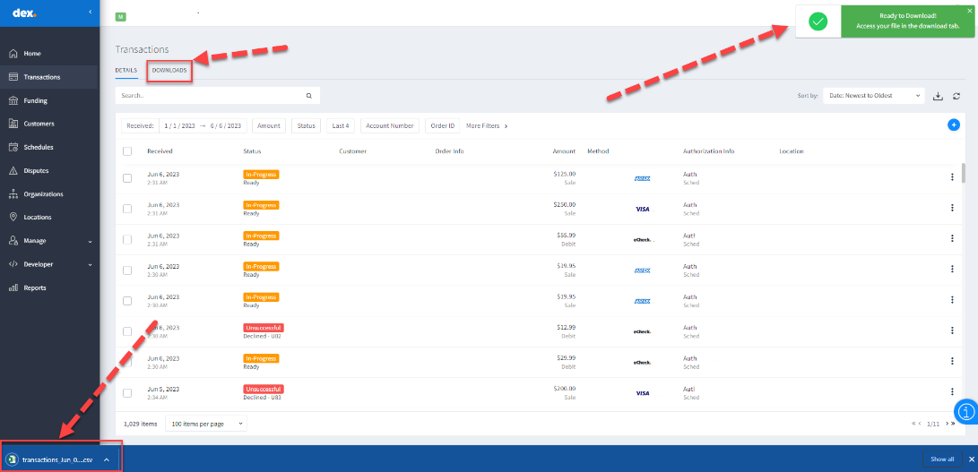

- Once the document has been opened in Excel, the best practice would be to highlight the description item fields that were added.
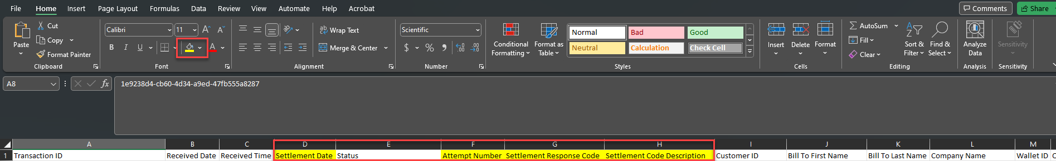

- To view transactions that have funded on the second or third attempt:
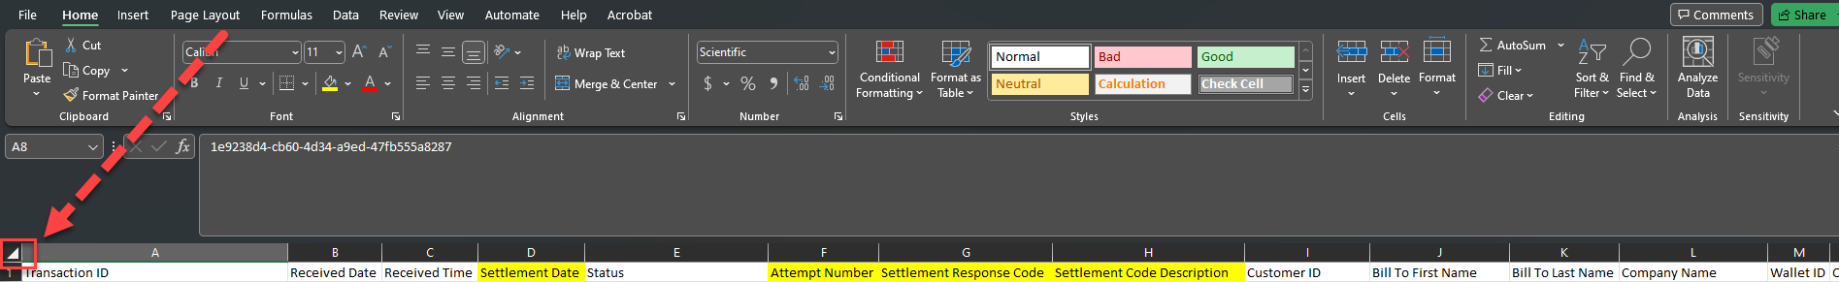
  - Select the triangle between Column A and Row 1. This will grey the entire spreadsheet, showing it has all been selected.
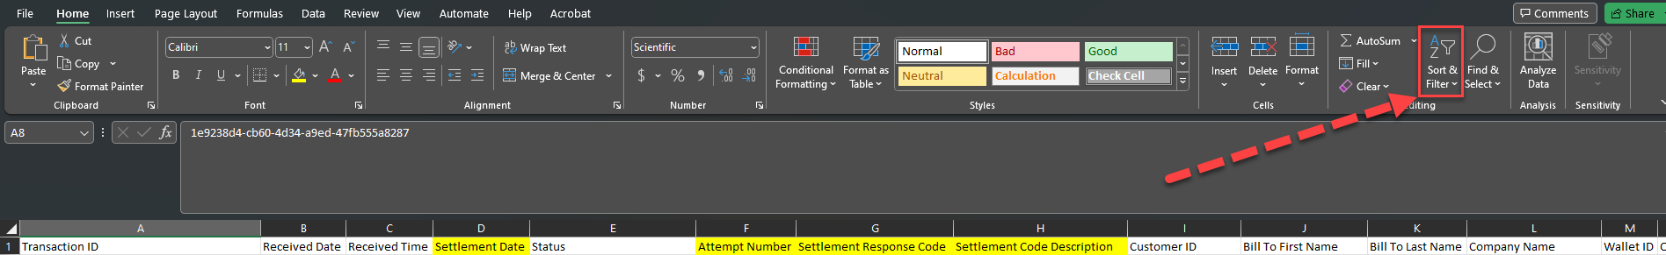
  - At the top right of the toolbar, Select Sort & Filter, then Filter.
  - You now can filter through each column depending on the information you would like to see.
  - Column F contains the Attempt Number, this can be filtered to show the 2nd and 3rd attempts.
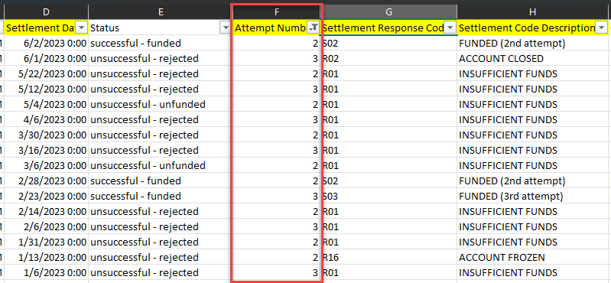
  - You now can filter by specific customer in column(s), J, K and L (Bill to First Name, Bill to Last Name, and Company Name).
  - For this example, CSG Forte filtered by John Smith and cleared the Attempt Number Filter to include 1st attempts.
  - Columns F, G, and H, indicate the attempt number, response code and response code description. Notice on the 3rd attempt, a response code of S03 was received, indicating it was Successfully funded on the 3rd attempt.
  - *In the example above, the dates are arranged by oldest to newest and the Received Date and Settlement Date correlate to each other.* (Subject to change)
  - To confirm that these transactions relate to each other, in Column S, Authorization Info, the authorization numbers are the same.
