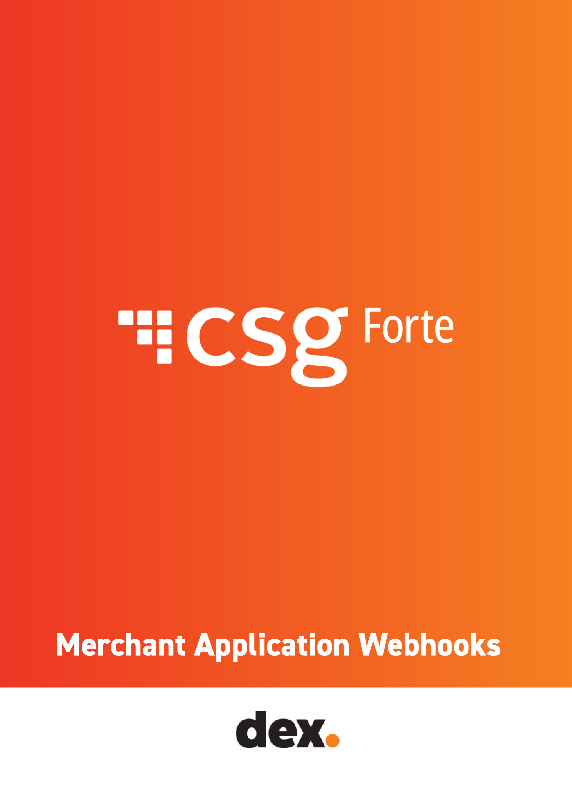Merchant Application Webhooks

Webhooks provide near-real-time notifications about the events that occur during the application process through POSTs to a customer-defined endpoint.
Merchant application webhooks provide the status of an application as the application status events trigger during the application process.
Partners can subscribe to the following merchant application webhook events:
- merchantapplication.approved
- merchantapplication.declined
- merchantapplication.pending
- merchantapplication.recalled
- merchantapplication.received
- merchantapplication.rejected
If a webhook post fails (i.e., does not result in an HTTP 200 response), Forte retries the webhook post up to twenty times adding one minute for each retry.

What information is included in the merchant application Webhook?

  - Organization ID
  - Event ID
  - Merchant Application
    - Application ID
    - Fee ID
    - Services Requested
    - Decline Reason
    - Rejected Reason
    - Recalled Reason
    - Status
    - Received Date
    - Received Time
    - Updated Date
    - Updated Time
    - Merchant DBA
    - Merchant Legal Name
    - Organization
    - Account id
    - DBA Name
    - Legalname
  - Source
  - Type
  - Environment

Parameter | Description
organization_id | Unique ID that identifies the partner Organization that sent the merchant an application
event-id | Random generated event id
MerchantApplication | The Merchant Application object
application_id | A unique, six-digit identification number that Dex created when the merchant submitted the application
fee_id | The ID of the rate plan, which details the fee values that Forte will charge the merchant. [max length = 6]
services-requested | The services included in the application. Supported values can be a combination of any of the following:  - eCheck Acquired  - Credit Card Acquired  - Credit Card Gateway  - Bank Account Status Verification – Validate  - Bank Account Status Verification - Validate+  - Bank AccountOwner Verification – Authenticate  - Account Updater  - BillPay  - IVR
decline_reason | The reason for a declined status. Supported values include the following:  - Identity  - Type of Business  - Reputation:
reject_reason | The reason for a rejected status. Supported values include the following:  - :Missing or Incomplete Pricing  - Incomplete or Invalid Bank Information  - Incomplete or Inaccurate TaxID/EIN  - Unable to Verify SSN  - Unable to Verify Date of Birth  - Invalid Signatures
recalled_reason | The reason for a recalled status. Supported values include the following:  - Incomplete Application  - Applicant not responding  - Partner Request
status | The status of the application. Supported values include the following:  - approved - Forte has approved the application and sent the merchant's data to the enrollment queue.  - pending - Forte's Credit and Risk Team needs to review the application and may request additional documentation from the merchant.  - declined - The application failed one or more automated underwriting checks and Forte has declined to move forward with the merchant. The reason for the decline displays in the decline_reason field  - received - Forte has received the application and will begin processing the request.  - rejected - Forte is unable to verify the identity data of an application or cannot authenticate the banking data or signatures. The reason for the rejected status displays in the reject_reason field  - recalled - The applicant has stopped responding to requests for information from Forte or the Partner. The reason for the recalled status displays in the recalled_reason field
received_date | The date when the application was received.
received_time | The time when the application was received.
updated_date | The date when the application was last updated.
updated_time | The time when the application was last updated.
account_id | Unique ID that identifies the partner Organization that sent the merchant an application.
dba_name | The name of the business as it will appear on your customer's statements. The default value for this parameter is the DBA (Doing Business As) Name. [max length = 50].
legal_name | The legal name of the business. The value of this parameter must match the name associated with the merchant's Tax ID Number. [max length = 50].
source | The source from which the merchant application was received  - RestApi  - Forte.Net  - Console
type | The merchant application status type. Supported values include:  - merchantapplication.received  - merchantapplication.approved  - merchantapplication.pending  - merchantapplication.declined  - merchantapplication.rejected  - merchantapplication.recalled
environment | The environment the application was processed in – “live”

How do I create webhooks for merchant application statuses?

Merchant application webhooks are available at the partner organization level.

To define your webhook, in Dex, select Developer > Webhooks from the Dex main menu and then click Create Webhook.

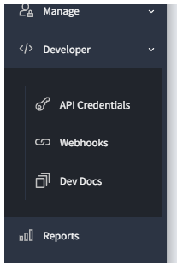

The following screen displays: Enter a unique Webhook name, set the status to Active or Pending, and enter the URL for your server which will receive the Webhook postbacks.
Define the events that trigger the Webhook using the Resource sections and actions, select All to receive webhooks for all resource actions, or Custom to specify which events trigger the webhook.

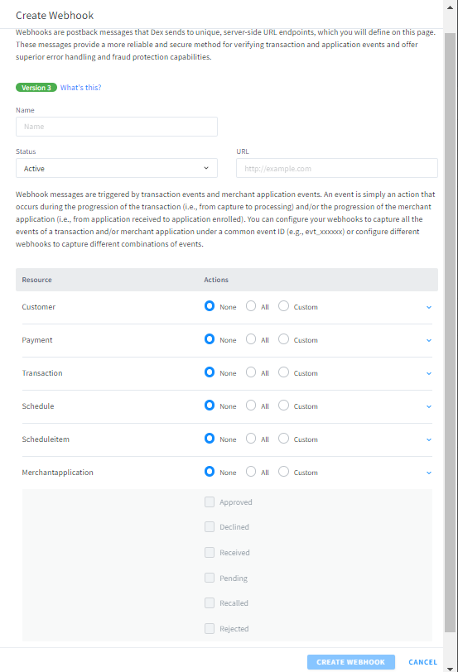

FAQs
- Is there a webhook for Enrolled status?

The team is currently working on the Enrolled webhook. Enrollment webhooks will be released in the second quarter of 2023.

- Can I set-up the application status webhooks for specific merchant organizations?

No, the application status webhooks must be set at a Partner org and includes all portfolios in the partner organization.

- What user in my Partner organization can create the application status webhooks in dex?

Users with one of the following roles can create application status webhooks in dex:
- Developer Role
- Api_User

If there are no dex users in your Partner organization with one of these roles, please reach out to your Forte contact to request the merchant application webhooks to be set-up for you.

- Can the application status webhooks be set up at the partner or the merchant organization?

No, application status webhooks are only available at the Partner org level.

- Can I choose which events I want to receive the application status webhooks for?

Yes, when setting up the merchant application webhook, choose custom to select the merchant application status webhooks you would like to receive.

- Can I select a time zone for the webhooks?

No, date and time fields are based on PST time zone.

Merchant Application Webhooks Sample Event Data

Approved:

{"organization_id":"org_123456","event_id":"evt_6AZrPxX2DUiZCZ3O5Qit3w","MerchantApplication":{"application_id":555555,"fee_id":11111,"services_requested":"eCheck - Acquired","decline_reason":[],"reject_reason":[],"recalledReason":[],"status":"approved","received_date":"01/29/2023","received_time":"11:38:12 PM","updated_date":"01/29/2023","updated_time":"11:45:16 PM","organization":{"account_id":123456,"dba_name":"test dba","legal_name":"test dba llc"}},"source":"Console","type":"merchantapplication.approved","environment":"live"}

Declined:

{"organization_id":"org_123456","event_id":"evt_PHfOvmHrukexY887o6uD6Q","MerchantApplication":{"application_id":555555,"fee_id":11111,"services_requested":"eCheck - Acquired","decline_reason":["Identity","Type Of Business","Reputation"],"reject_reason":[],"recalledReason":[],"status":"declined","received_date":"01/29/2023","received_time":"11:38:12 PM","updated_date":"01/29/2023","updated_time":"11:38:57 PM","organization":{"account_id":123456,"dba_name":"test dba","legal_name":"test dba llc"}},"source":"Console","type":"merchantapplication.declined","environment":"live"}

Pending:

{"organization_id":"org_123456","event_id":"evt_oONZb8MyN0eelUyVRnYkqQ","MerchantApplication":{"application_id":555555, "fee_id": 11111,"services_requested":"eCheck - Acquired and Credit Card - Acquired","decline_reason":[],"reject_reason":[],"recalledReason":[],"status":"pending","received_date":"03/02/2023","received_time":"12:15:54 PM","updated_date":"03/02/2023","updated_time":"12:16:02 PM","organization":{"account_id":123456,"dba_name":"test dba","legal_name":"test dba llc"}},"source":"Console","type":"merchantapplication.pending","environment":"live"}

Received:

{"organization_id":"org_123456","event_id":"evt_LOJOqbKXI0K2KifqPaxrrQ","MerchantApplication":{"application_id":555555,"fee_id":11111,"services_requested":"eCheck - Acquired","decline_reason":[],"reject_reason":[],"recalledtReason":[],"status":"submitted","received_date":"01/29/2023","received_time":"10:32:15 PM","updated_date":"01/29/2023","updated_time":"10:32:15 PM","organization":{"account_id":123456,"dba_name":"test dba","legal_name":"test dba llc"}},"source":"forte.net","type":"merchantapplication.received","environment":"live"}

Rejected:

{"organization_id":"org_123456","event_id":"evt_BIcR-xdph0OwKBZVNXL8Dg","MerchantApplication":{"application_id":555555,"fee_id":11111,"services_requested":"eCheck - Acquired","decline_reason":[],"reject_reason":["Missing or Incomplete Pricing","Incomplete or Invalid Bank Information","Incomplete or Inaccurate TaxID/EIN","Unable to verify SSN","Unable to verify Date of Birth","Invalid Signatures"],"recalledReason":[],"status":"rejected","received_date":"01/29/2023","received_time":"11:38:12 PM","updated_date":"01/29/2023","updated_time":"11:42:20 PM","organization":{"account_id":123456,"dba_name":"test dba","legal_name":"test dba llc"}},"source":"Console","type":"merchantapplication.rejected","environment":"live"}

Recalled:

{"organization_id":"org_123456","event_id":"evt_i62YX16Q2k-DWVS7NhYlUg","MerchantApplication":{"application_id":555555,"fee_id":11111,"services_requested":"eCheck - Acquired","decline_reason":[],"reject_reason":[],"recalledReason":["Incomplete Application","Applicant Not Responding","Partner Request"],"status":"recalled","received_date":"01/29/2023","received_time":"11:38:12 PM","updated_date":"01/29/2023","updated_time":"11:44:07 PM","organization":{"account_id":123456,"dba_name":"test dba","legal_name":"test dba llc"}},"source":"Console","type":"merchantapplication.recalled","environment":"live"}

For more information on Webhooks please see:

Understanding Webhooks https://www.forte.net/devdocs/reference/webhooks.htm

