Setting Merchant Credentials within Dex

This tutorial guides a merchant with setting production credentials within the Dex portal. Access to Dex is by invitation with a role Merchant Admin, or greater.
Pro-Tip
- An Organization, formerly known as an Account, is assigned based on the business’ Federal Tax ID. The Organization ID is displayed in the upper left-hand corner, next to a green box with an “M”, immediately below the business name.

For example: 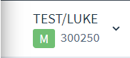
- An organization may have one or more locations. Each Location is assigned a Location ID. Locations are used to process transactions. Locations can be viewed by clicking on the Locations bar, at left. The datagrid of results for each will display the location name and the location ID.

For example:

- Login to your account – https://login.forte.net
- Enter the email address and password associated with the accepted invitation.
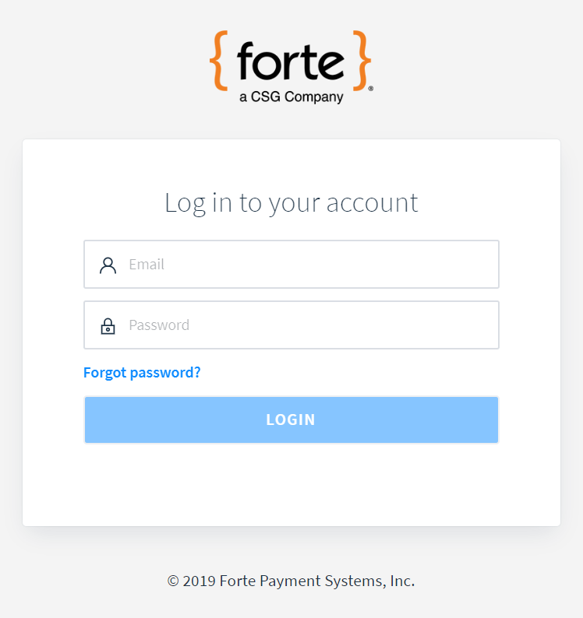

In prelude, two notes:
Switch between login accounts and/or environments by clicking the user profile picture, in the upper right-hand corner. Two environments are available: live or sandbox. Credentials are set independently per environment.

Contact your software vendor or payment solution provider for assistance identifying which credential(s) from step #2 and step #3 below are required for setup. The software vendor or provider can offer guidance on credentials needed from Dex and how these credentials are to be applied in setup.

- Set API Credentials used by these APIs: Forte Checkout auth version 2.0 and RESTful webservices. For this, simply the ‘Merchant Developer’ user role (or higher) is required.

  - At left, click the Developer bar.
  - Click the “API Credentials” option.
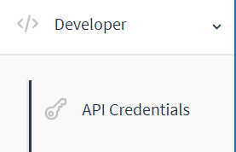

  - Click the blue “CREATE” button, upper-right hand side.
  - Enter a name for this new set of API credentials, e.g.: “Key for my accounting software”.
  - Click the blue “CREATE NEW API KEY” button.
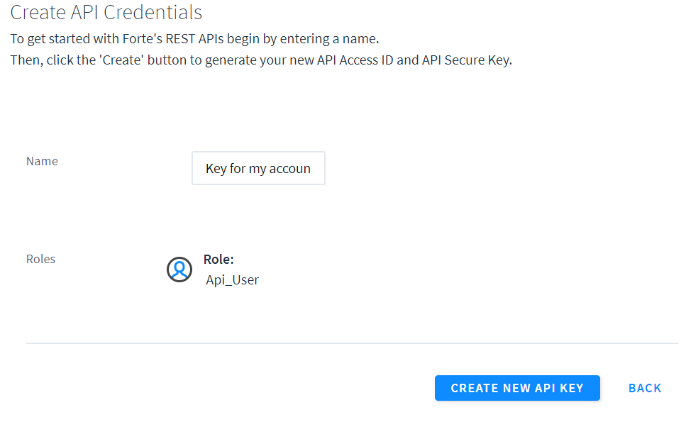
  - Click the copy link below each element – API Access ID and API Secure Key

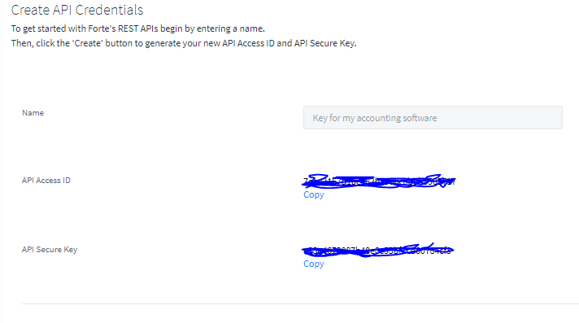
  - Apply newly set credentials to your integrated system.

- Set credentials used by these APIs: Advanced Gateway Interface (AGI), Batch, Forte Checkout auth version 1.0, Forte JS, Secure Web Pay (SWP) family, and SOAP “Client” “Merchant” “Transaction” webservices
  - At left, click the Locations bar.
  - From the datagrid of results, click on the appropriate location record to manage.
  - Click CREDENTIALS, a tab across the top of the location detail record.

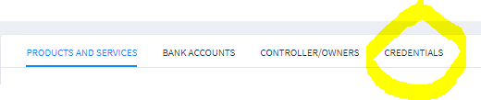

Pro-Tips
  - FTP Password is generally known as the “Transmitter” password.
  - The masked portion of the FTP Username is known as the “Transmitter ID”.
  - Credentials previously managed within Virtual Terminal (https://vt.paymentsgateway.net > Gateway Settings > Gateway Key > API Login ID and Secure Transaction Key) are referred to as: “API Login” and “Secure Transaction Key”.

  - The credentials page will be displayed. New values may be set by clicking the “Regenerate” link below the credential or credentials needing to be changed.

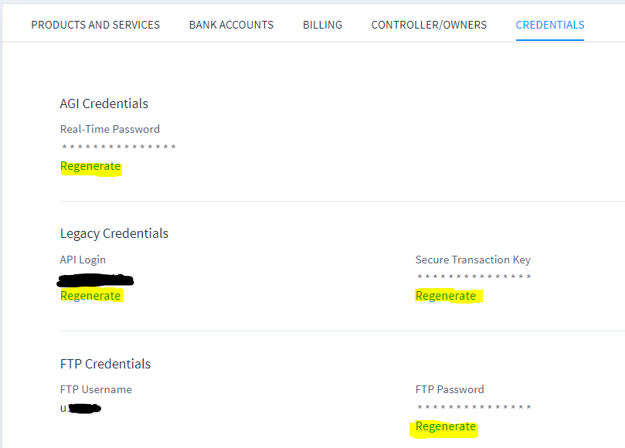

  - Apply newly set credentials to your integrated system.

